SKILLS MATRIX:

- The following table sets out the skills, knowledge and personal qualities which are essential or desirable for role of Chief Executive.
Table 1 – Skill Matrix
 | Essential | Desirable
Skills
Strong strategic skills with ability to exercise sound judgement in reaction to the handling of complex and sensitive issues. | √
Excellent interpersonal skills with the ability to communicate effectively both with public audiences and with individuals. | √
Ability to work constructively as a leader and as a part of a team with the Board and its committees, staff and stakeholder groups. | √
Sound leadership and management skills. | √
Knowledge
Understanding of and commitment to principles of corporate governance in the public sector. | √
Knowledge of the criminal justice system and its place in the current political and legislative context in Scotland. | √
Knowledge of offender risk assessment and management research and practice. |  | √
Experience
Management experience in setting and implementing strategy. | √
Experience of performance management | √
Operational and management experience of working with serious offenders. |  | √

CHIEF EXECUTIVE JOB DESCRIPTION
1. JOB DETAILS
Job Title  LINe MANAGER  GRADE | Chief Executive  Board Convener  Grade CE

2. JOB PURPOSE
To lead the RMA operations in order to effectively discharge its statutory obligations to help to protect the public and make Scotland a safer place to live and work.
To influence senior stakeholders across the Scottish Criminal Justice system to improve current practice in the management of serious violent and sexual offenders through establishing and operating effective standards, accreditation, approval and governance approaches.
To lead the RMA in researching, shaping and proposing Scottish wide policy relating to best practice approaches to risk assessment and management of serious violent and sexual offenders.

- ORGANISATION CHART

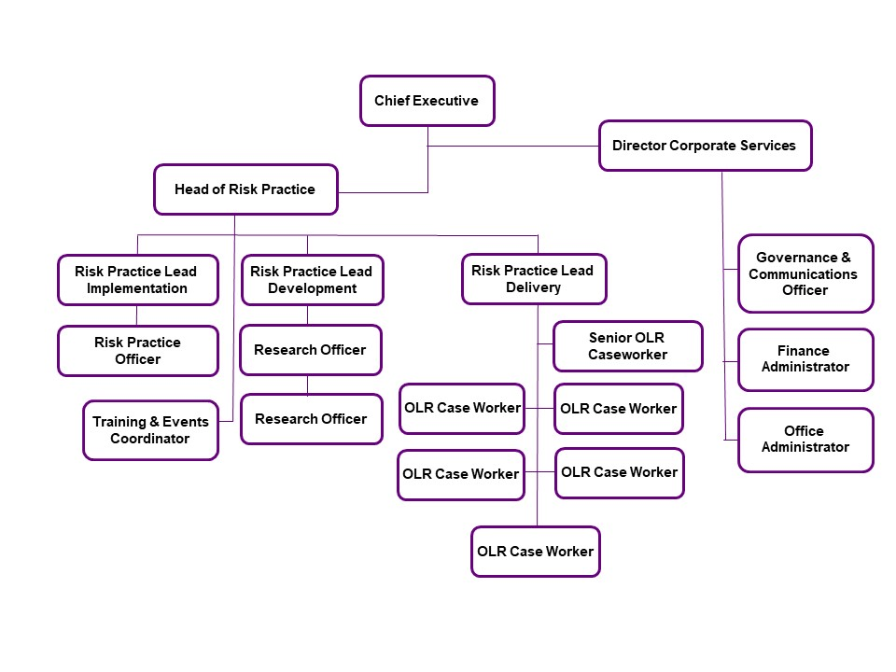
- DIMENSIONS
Important dimensions include:
Organisational budget - circa £1.3m
Staff numbers – up to 20 staff (with 2 direct reports)
Board – Convener and 8 Board members (Accreditation Committee, Audit Committee, Remuneration Committee)
Stakeholders/Lead Agencies – Scottish Government Justice Directorate and Safer Communities Directorate, NHS Scotland, Local Authority Social Work Directorates, Police Scotland, Scottish Prison Service, Parole Board for Scotland, accredited individual practitioners

- MAIN ACCOUNTABILITIES
- To lead the delivery of all RMA statutory functions to ensure effective practice in the risk assessment and management of serious violent and sexual offenders in Scotland.

- To lead the development and delivery of a range of initiatives, policies and practices that promote effective risk practice nationally.

- To lead RMA functions in relation to the Order for Lifelong Restriction ensuring that robust, defensible decisions are made in the approval of risk management plans and the review of annual implementation of such plans, issuing guidance to lead Authorities as required.

- To oversee the staff evaluation of risk management plans and annual implementation reports; ensure the implementation of appropriate controls and escalation processes. To provide professional advice and guidance to staff on risk assessment and risk management procedures.

- Authority and responsibility to make decisions on the approval or rejection of risk management plans and issue guidance to Lead Authorities in accordance with the relevant legislation, published standards and in line with the Scheme of Delegation.

- Ensure that the RMA sets and published standards that reflect current research and best practice, and so promote effective practice, and that are disseminated and communicated effectively.

- To lead engagement, internally and nationally, to deliver and develop the national policy with regards to risk assessment and management, ensuring that Board/Scottish Government/Stakeholders receive the information and advice they need to meet their statutory obligations and all governance requirements.

- To build the RMA’s reputation as a forward looking organisation, committed to excellence, and so generate strong demand for advice and expertise. This will include presentations at conferences, stakeholder groups, and learning events, and taking every opportunity to act as an ambassador for the Authority.

- To develop and sustain a complex range of effective relationships with key senior stakeholder groups in order to develop best practice approaches, challenge current practice/set standards, and create the desire and momentum to change and implement improvements.

- To be the public face of the RMA in dealing with Scottish Government, political commentators and other sections of the media, informing statute and policy in order to ensure that an informed debate on risk assessment and management takes place in the interests of public safety and confidence across Scotland.

- To seek out and understand international developments in risk assessment and management and evolving best practice in order to enhance policy development and reinforce the contribution made by the RMA. Develop and sustain senior level organisational and professional expertise through links with other jurisdictions and the research community.

- To lead the management team in creating a high performing organisational culture that maximises the contribution of staff, both as individuals and in teams, so that the organisation can continue to learn, change and deliver maximum contribution to public value.

- To direct the development and implementation of the RMA’s Corporate and Business Plan and projects to deliver the organisation’s purpose, vision, strategy and objectives. To review performance and ensure that robust reporting arrangements are in place so that progress against plan can be monitored and managed. To monitor the future resource requirements and work closely with the Director of Corporate Services, Heads of Delivery and Development to ensure business objectives are delivered on time and to budget.

- To act as Accountable Officer for the RMA, with responsibility for the budget and management of RMA processes and compliance with the requirements of the RMA Sponsorship Framework.

6. LEVEL OF AUTONOMY AND DECISION-MAKING
The Chief Executive is accountable to the RMA Convener and Board and operates within the level of autonomy and decision making as outlined within the Scheme of Delegation. This delegates the majority of functions to the Chief Executive; the Board retains decision making in relation to awarding of accreditation as required by legislation, and the issuing of directions to lead Authorities. The post is self-directed as informed by the strategy and business plan approved by the Board and Scottish Ministers, represented by the Scottish Government Justice Department sponsor.

7. COMMUNICATIONS
The CE has a critical role in building effective working relationships such that they communicate expectations, challenge delivery and performance, and advise on best practice and required change across the Scottish Criminal Justice system. The CE is engaged in developing and improving Scotland wide policy on managing risk in a complex multi-agency landscape, and regularly engages with

- Senior staff within the Scottish Government Justice Department, working collaboratively and providing policy guidance and advice on relevant issues.
- Key senior colleagues within other Scottish Government directorates – Safer Communities, Health, Education
- Senior colleagues within Lead Agencies involved in criminal justice in order to provide advice on understanding and adopting current best practice, effect sharing and improving practice, and to influence the development and implementation of new system wide standards and approaches.

Key internal relationships are with:
- The RMA Convenor and Board Members, either informally or at Board or Committee meetings to provide advice, progress reports, information etc.
- With members of the Senior Management Team – to provide leadership on organisational direction and to set the tone and culture of the organisation
- RMA staff – provide strategic and operational leadership on performance and standards of all aspects of RMA remit

8. COMPLEXITY
The main sources of complexity and challenge in the CE role are:
- Influencing across the significant operational scale of the Scottish criminal justice system where the CE of RMA can’t compel, finance or mandate change generally.
- Delivering guidance to Lead Authorities on specific cases when practice falls below the required standard, maintaining constructive dialogue to ensure that guidance is regarded while promoting resolutions that avert escalation.
- As the leader of a small public body, delivering the optimal balance of research and innovation with the growing demands and complexity of case work.
- Working to maintain attention to continued improvement in risk practice amidst competing demands (within and across criminal justice organisations) and changing policy priorities (at national, organisational and service level).
- The need to safeguard and maintain the independence of the RMA.

9. EXPERIENCE, KNOWLEDGE AND SKILLS REQUIRED
- The post holder must be credible across a range of senior organisational and government stakeholders and will have a significant background in the complex issues associated with public protection and managing risk in a complex multi-agency landscape.

- The post holder is subject matter expert within the Scottish Criminal Justice System on the effective risk assessment and management of serious sexual and violent offenders. This level of authoritative expertise will have been gained through sustained career success in the criminal justice social work/forensic psychology/criminal or human rights law/ academic system.

- The CE operates at a senior level in the Scottish policy landscape; leading initiatives that involve research, developing and influencing change, and the promotion of best practice in the management of violent and sexual offenders to assure public safety. Sound experience of leading such initiatives and collaborating with others around the development and implementation of national policy is essential.

- The post holder must demonstrate strong interpersonal skills. The RMA effects policy and practice improvement and change through influencing and convincing others of the merits of the approach – without being able to exercise financial or organisational control. This requires a proven ability to develop and sustain effective working relationships at a senior level in a complex system, and through offering appropriate challenge and collaboration.

- The post holder must have senior level managerial and organisational experience. The CE has critical roles to play as Accountable Officer and in managing the Board, and proven success in leading internal and external strategy and governance processes is required.

